**APS 1050: Blockchain Technologies and Cryptocurrencies**

*An automobile Auction House*

Instructions for Setup



University of Toronto

Ziyan Zhao 1007212927

Lizhen Qiao 1008651585

# Introduction

This documentation contains detailed instructions to set up the automobile DApp. This DApp used the Truffle and Ganche framework, and included JQuery framework as frontend. All the dependencies and their versions used for this project as stated below.

* Truffle v5.1.10
* Node.js v14.16.1
* lite-server 2.6.1
* Solidity 0.5.16
* web3 1.7.5
* Ganache v2.5.4
* json-server 0.17.0

Install the Truffle IDE globally from the windows terminal:

npm uninstall -g truffle

npm install -g truffle@v5.1.10

Install liteserver globally from the windows terminal:

npm install -g lite-server

or goto: <https://www.npmjs.com/package/lite-server>

Install json-server globally from the windows terminal:

npm install -g json-server

# Instruction for running the DApp

## Running Ganache

Run and open Ganache. Choose the quickstart mode. You should see Ganache started at <http://127.0.0.1:7545>. In the Accounts tab you should see 10 addresses each with 100 tesntet ether. You can check other information by clicking other tabs on the top (blocks, transactions, contracts, events, logs).

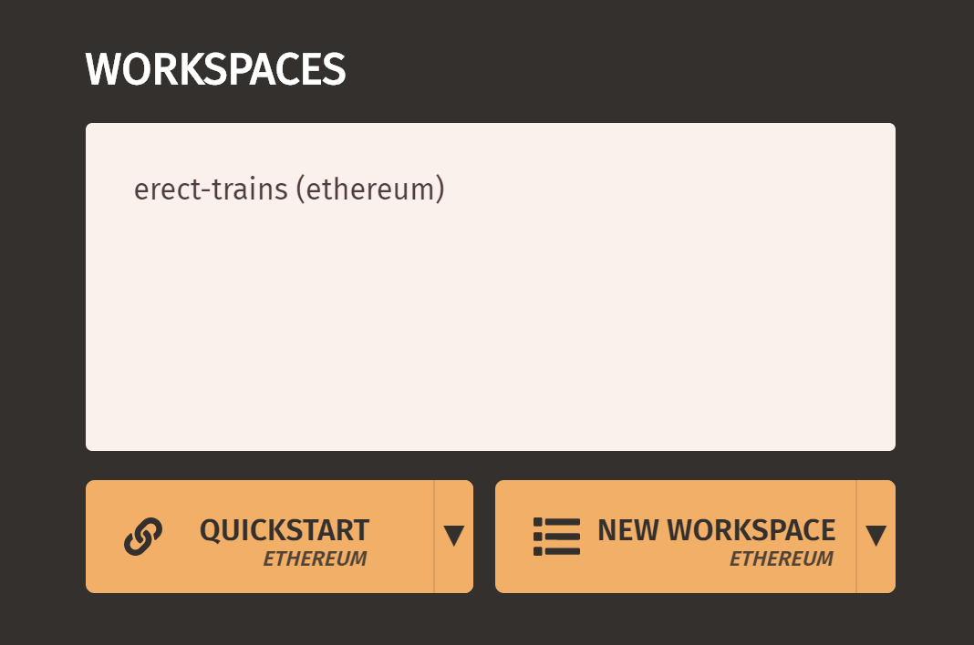

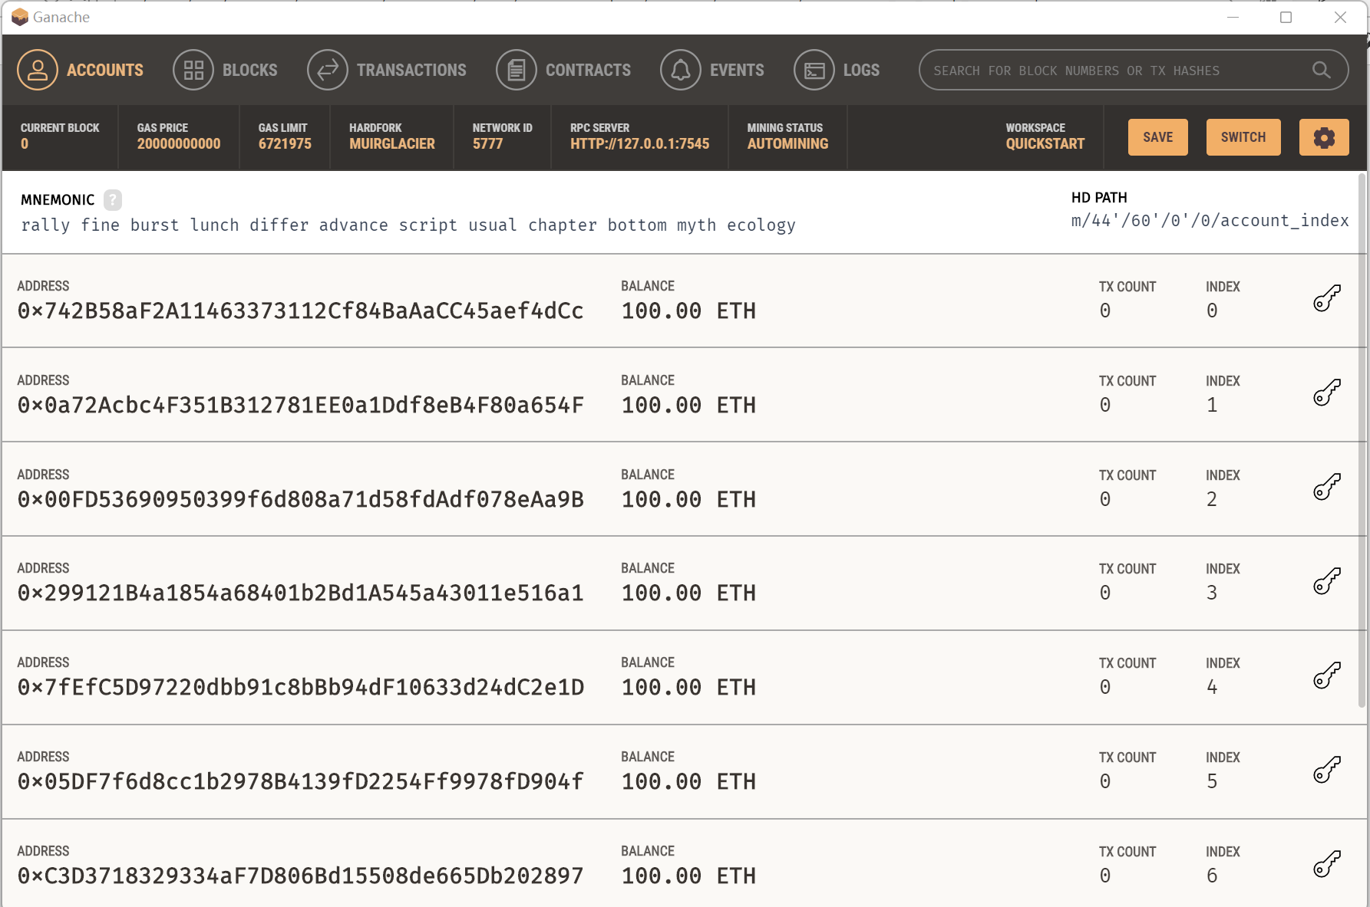

## Connecting MetaMask to Ganache

Install MetaMask in your default browser. Import your Ganache account into MetaMask using the twelve MNEMONIC words.

Go to Main Ethereum Network Dropdown List (top right), and select Custom RPC. Copy RPC server address from Ganache (should be HTTP://127.0.0.1:7545) and paste it to New RPC URL. In the Chain ID field write Ganache's Chain ID: 1337. Click save.

You will find you add a network as follows.

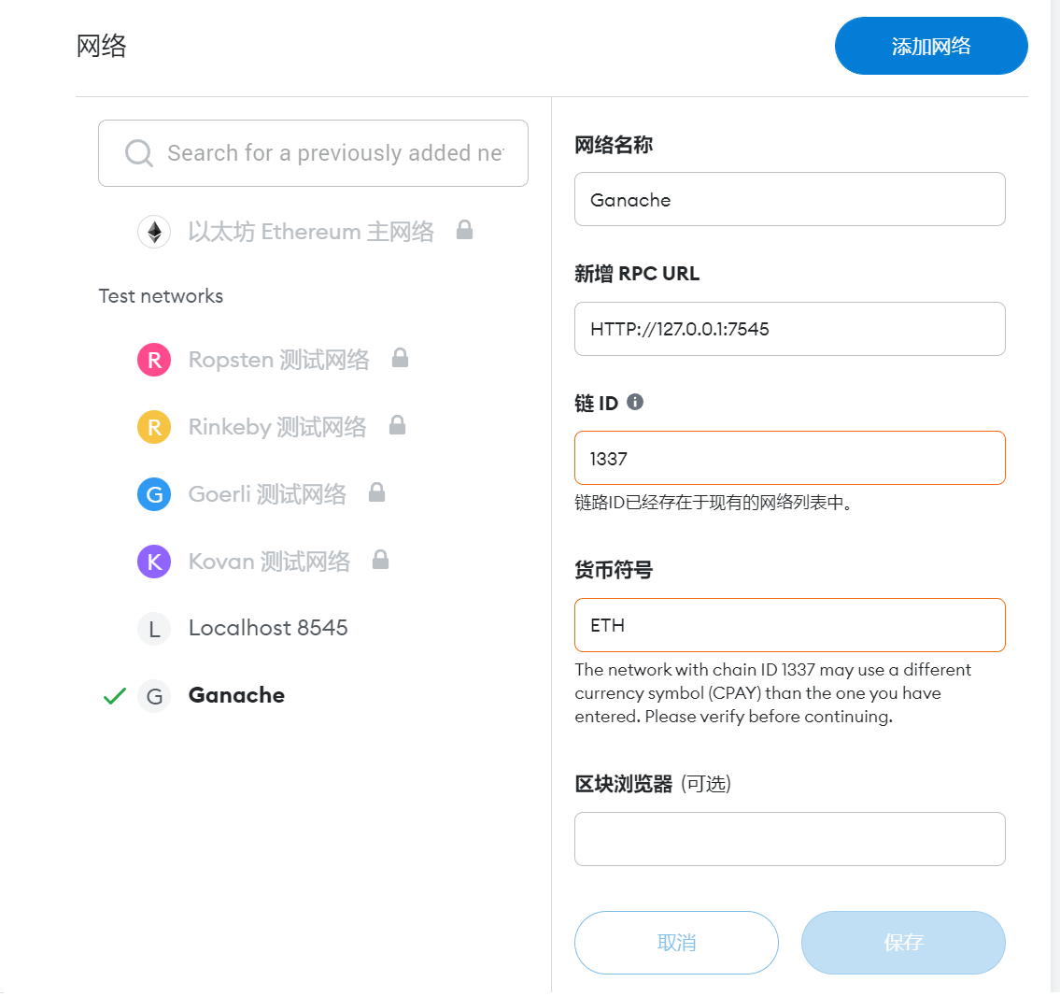

Now you can see your account with 100 ETH.

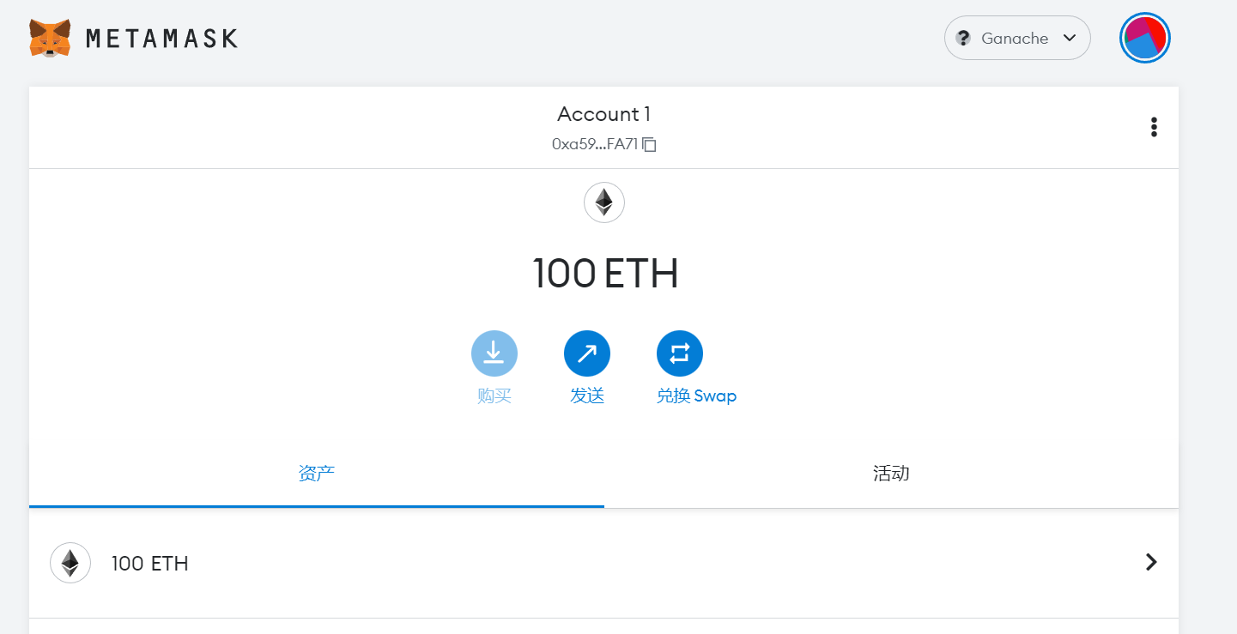

## Running the DApp

Enter the project directory. Open the windows terminal, and run command: truffle migrate –reset. You will see the contract has been successfully migrated.

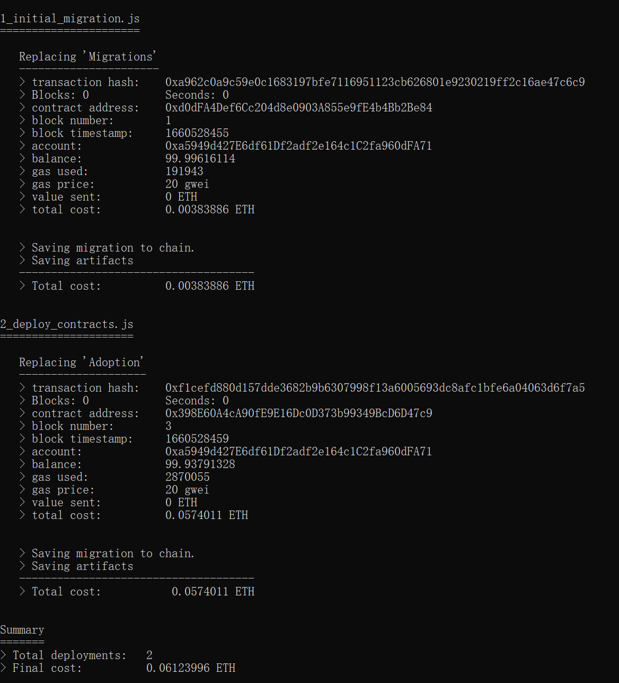

Next run command: npm run dev.

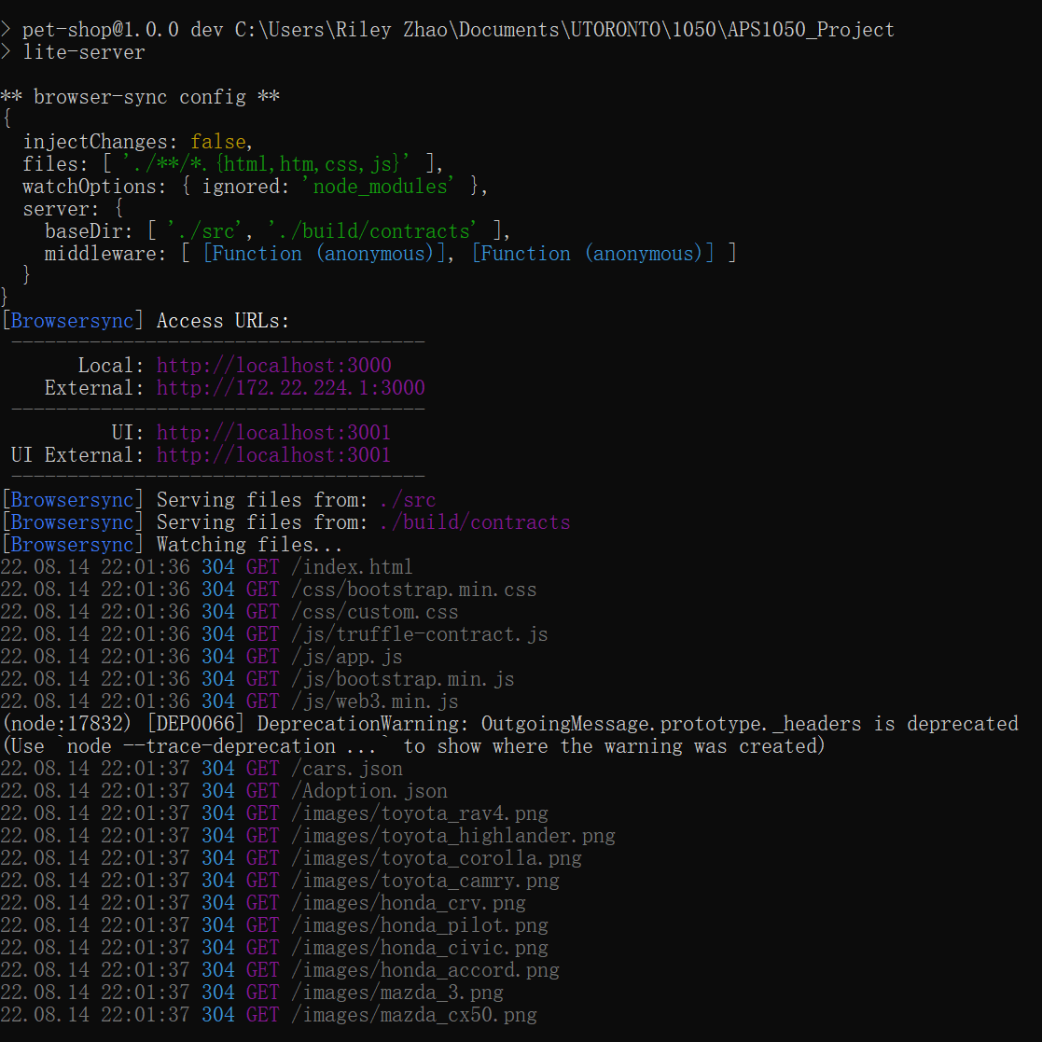

The app will automatically start at localhost:3000

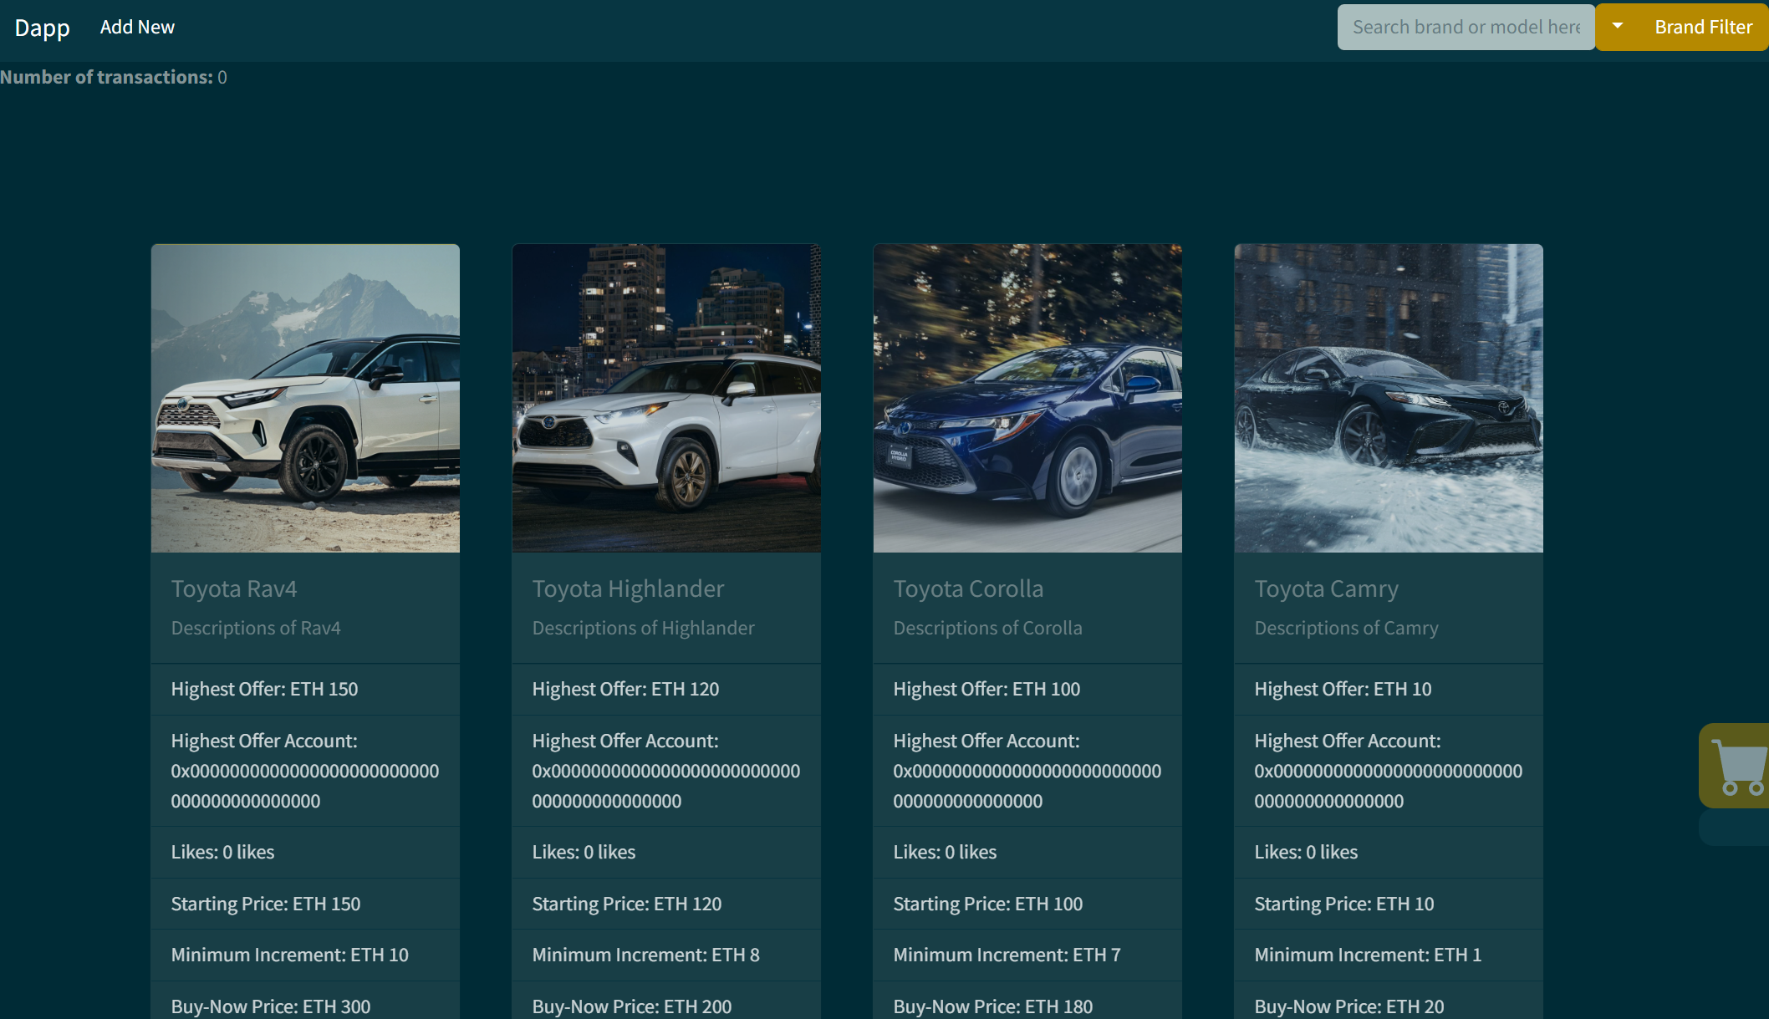

Finally run command: json-server --watch --port 4000 src/cars.json. This helps watch some data change in json.